**Science: The Human Body/Light & Sound**

By working scientifically, we will identify and group animals with and without skeletons by observing and comparing. We will explore ideas about what would happen if humans did not have skeletons and investigate the special functions of different body parts including the digestive system and the importance of our teeth. Additionally, we will be learning about light and sound to include what we need to see and that sound should be associated with something that is vibrating and that it travels through a medium to the ear.

**Geography: Rivers**

We will continue to build on our locational knowledge of the World to investigate and explore the physical geography of rivers. This will enable the children to describe and understand the key aspects of rivers using a high level of technical vocabulary.

**Art & Design: Sculpture**

We will study the work of Barbara Hepworth and learn how to improve our mastery of art and design techniques, including drawing and sculpture with a range of materials including clay.

What challenges face the modern world today?



**Numeracy:** Our Maths this term will cover the following areas:

**Place Value** where we will be problems solving to help us identify, represent and estimate numbers;

**Addition and subtraction** using more formal written methods eg. column method;

**Multiplication and division** with a strong focus on our knowledge and recall of our times tables knowledge.

**English: Fiction and non-fiction texts**

**Fiction:** . 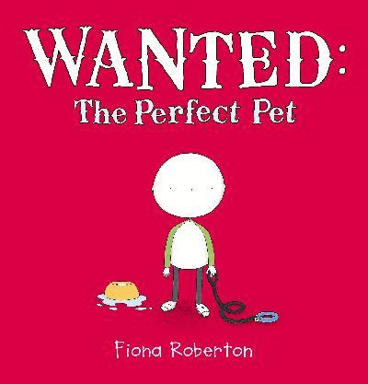 A fiction text that teaches a range of sentence structures, the subtleties of inference and provides lots of opportunities for role play and PSHE activities to promote empathy.

**Non- Fiction**: Book of Bones: 10 Record-Breaking Animals, Gabrielle Balkan.

A non-fiction text that is structured in a different way from a tradition reference book to encourage a positive attitude for reading. It will teach the children how to extend sentences using a range of conjunctions and the manipulation of main and subordinate clauses as well as the use of appropriate pronouns and the possessive apostrophe.

**History: The Anglo Saxons & Scots/United Arab Emirates**

We will discover all about the everyday lives of the Anglo Saxons and Scots and then compare this period in history with modern life in the United Arab Emirates. This will enable us to identify the different challenges that people have faced over the centuries and explore the reasons for and results of people's actions.

**SMSC:**

This term will focus on the core values that will encourage us to be respectful, resourceful and resilient through our Social, Moral, Social and Cultural curriculum.

*If you have any resources at home that could help to support the class in their learning, and would be prepared to bring them into school, then these would be gratefully received.*

**With many thanks in advance for your support,**

**Mrs Gardner**

**Physical Education**:

Children will be encouraged to develop their skills in hockey and netball this term and apply basic principles suitable for attacking and defending. They will be taught to use communication and collaboration and interact competitively with each other to develop an understanding of how they can improve in different physical activities to achieve their personal best.