All children are expected to complete the following each week please:  - Spellings.  - Multiplication and division facts.  - Regular reading-3-5 times a week. Even though the older children may be reading independently it is still important that an adult listens to and discusses the text being read.  - One piece of English/Maths work. | Suggested task 1-mapwork.
 | Google Earth lets you fly anywhere on Earth to view satellite imagery, maps, terrain and 3D buildings, from galaxies in outer space to the canyons of the ocean!! Choose from the google Earth Task Cards provided and see what amazing facts and information you can find. Choose how you want to present your findings, write, draw, create a powerpoint?
 | earth.google.co.uk
 | 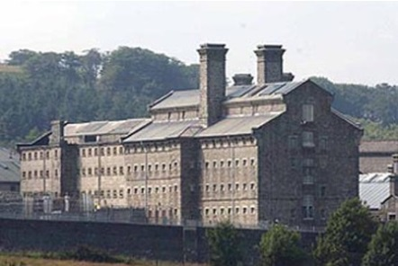  Suggested task 2- local history. | Think of a local place you are interested in such as Dartmoor Prison,Morwellham Quay, Lydford Castle or Castle Drogo. Put together a quiz abou the history of your chosen place. Your quiz should have multiple choice answers. Bring it to school to try out on your classmates.
The weekly homework will be set on a Monday and reviewed on the following Monday. Please remember that the children should be able to attempt the homework independently but do support them by asking about the activity or sharing it when it is done. If your child has any issue just ask them to speak to myself or Mrs Simmons if any further clarification or support is needed. Homework should be a consolidation of the learning taking place in school.
The suggested tasks are for those children who would like to do some additional ‘project’ work. This work can be brought into school during the week of May 16th when it will be shared and celebrated. All homework will be awarded Team Points for effort and achievement. Please note that the Year 6 homework club is in addition to this. As SATs are looming we totally understand if the Year 6 children want leave the suggested tasks to concentrate on Maths and English. Thank you. Miss Paton
 | Suggested task 3-Be a still life artist!
 | 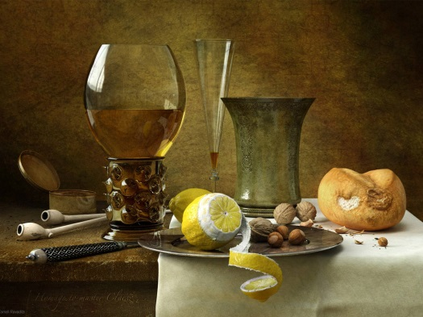 | A still life is a work of art depicting mostly inanimate subject matter, typically commonplace objects which may be either natural or man-made. Look for objects around the house or garden, arrange your collection and then draw and/or paint them.

