HOMEWORK SPRING TERM 2018  All children are expected to complete the following at home each week:  - Spellings/ times table practice  - Reading aloud to an adult at home - 3-5 times a week  - One piece of English/Maths work linked to learning in class | Suggested task 1
RESEARCH an aspect of global trade.
You could choose from one of the following:
- Rice in India
- Sugar in Malawi
- Honey in Chile
This can be presented in any way you choose eg. poster, power point, art work, baking.
 | Suggested task 2
Create a factual poster about a group of living animals that interest you. Think about their:
- habitat
- food
- life cycle

Weekly homework will be set on a Tuesday and is due in the following Monday. Please remember that the children should be able to attempt the homework independently but do support them by asking about the activity or sharing it when it is done. Homework tasks consolidate learning taking place in school.

The suggested tasks are for those children who would like to do some additional ‘project’ work. This work can be brought into school during the week of February 5th when it will be shared and celebrated in an assembly.

Thank you for your ongoing support with your child’s home learning,

Mrs Petersen
 | Suggested task 3
 | 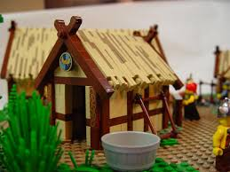 | Design a Viking village. Use any materials that you can find to create this miniature world. Find out about the world our Viking ancestors lived in to inspire you.  Have fun!

