Dartmoor Class
HOMEWORK Autumn TERM 2017  All children are expected to complete the following each week:  - Spelling/times tables practice  - Reading aloud to an adult at home – at least 3 times a week.  - One piece of English/Maths work | Suggested task 1
Science/D.T. -
Invent a piece of electrical equipment that may help you get ready for school. You can make a basic prototype or draw a technical design and label its components.
 | Suggested task 2
 | 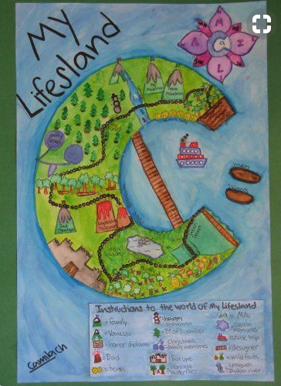 | Geography/Art -  Create an imaginary Island for an Aztec community. You can make/draw the island, its location and natural resources needed to support the historic population.  For example, you can use Lego, cardboard or draw a geographical map. Challenge yourself to create a key!
Weekly homework will be set on a Monday and is due in the following Monday. Please remember that the children should be able to attempt the homework independently but do support them by asking about the activity or sharing it when it is done. Homework tasks consolidate learning taking place in school.

The suggested tasks are for those children who would like to do some additional ‘project’ work. This work can be brought into school during the week beginning DEC 4th when it will be shared and celebrated in an assembly on Wednesday 6th December.

Thank you for your ongoing support with your child’s home learning,
Miss Cox
 | Suggested task 3
 | 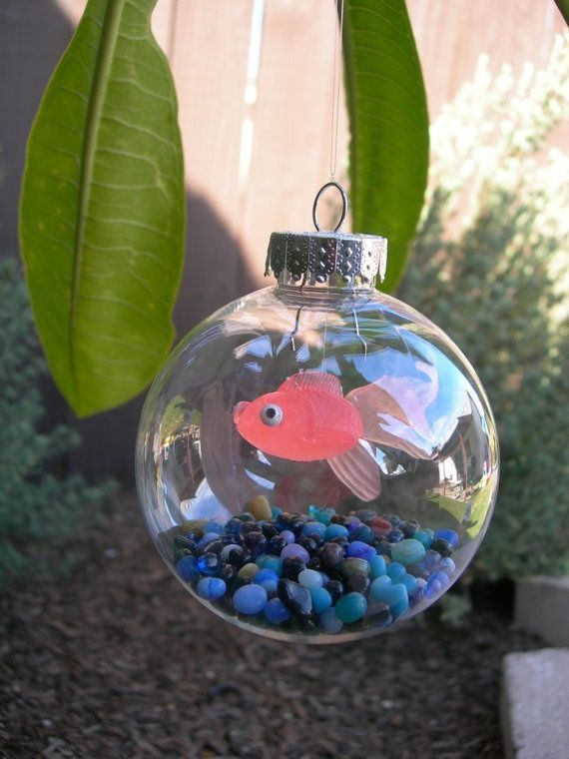 | Create a unique Christmas tree decoration for our school tree. Make a hanging decoration from any materials you can find. You may want to sew fabric or decorate a bauble.  HAVE FUN!

