HOMEWORK Spring 1 TERM 2018  All children are expected to complete the following each week:  - Spelling practice weekly  - Reading aloud to an adult at home – at least 3 times a week (please record in your child’s Reading Record even if your child is reading independently)  - One piece of English/Maths work weekly  - Times tables or Mental Maths practice | Suggested task 1
 | 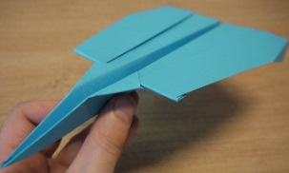 | Make a paper aeroplane or a paper boat. Yr1 and Yr2 write instructions on how to make it.
 | Suggested task 2
 | 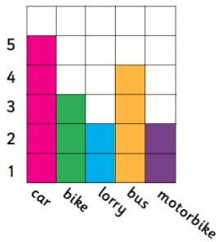 | Make different types of paper aeroplanes, measure. Yr1 and Yr2 also record how far each one can fly. Can you record it in a block graph?
Weekly homework will be set on a Tuesday and is due in the following Monday. Please remember that the children should be able to attempt the homework independently but do support them by asking about the activity or sharing it when it is completed. Homework tasks consolidate the learning taking place in school.

The suggested tasks are for those children who would like to do some additional ‘project’ work. This work can be brought into school during the week of February 4th when it will be shared and celebrated in a homework assembly.

Thank you for your ongoing support with your child’s home learning,

Mrs Petersen
 | Suggested task 3
 | 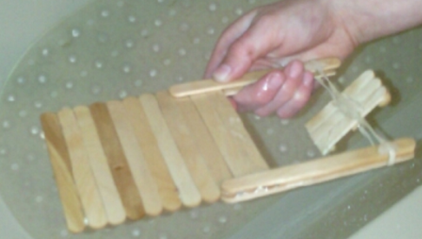 | Create your own floating boat and design a way for it to move.

