HOMEWORK Summer Term 2018  All children are expected to complete the following at home each week:  - Spellings/ times table practice  - Reading aloud to an adult at home - 3-5 times a week  - One piece of English/Maths work linked to learning in class | Suggested task 1
 |  | Grow a plant of your choice. This could be a flowering plant or a vegetable to eat. Care for your plant to nurture it. Bring it into our Homework assembly for all to admire! Get growing!
 | Suggested task 2
 | 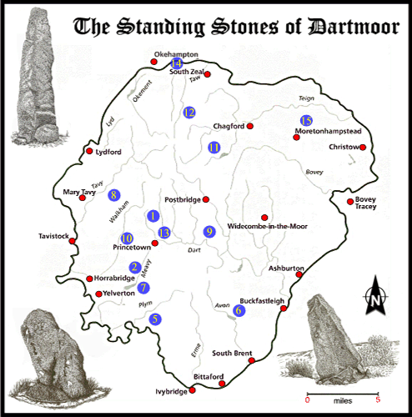 | Create a power point on an area of Dartmoor that you are interested in. You can include:  - Historic information  - Geographical facts  - Images/ photographs
Weekly homework will be set on a Tuesday and is due in the following Monday. Please remember that the children should be able to attempt the homework independently but do support them by asking about the activity or sharing it when it is done. Homework tasks consolidate learning taking place in school.

The suggested tasks are for those children who would like to do some additional ‘project’ work. This work can be brought into school during the week of June 11th when it will be shared and celebrated in an assembly.

Thank you for your ongoing support with your child’s home learning,

Mrs Petersen
 | Suggested task 3
Get cooking with FRUIT! Use a variety of fruit to make a design of your own – this could be a smoothie, cake, fruit salad, kebab – whatever you like! You can also write a recipe/ method using instructional writing.

Have fun!

