ENGLISH

Texts we will cover this term include:

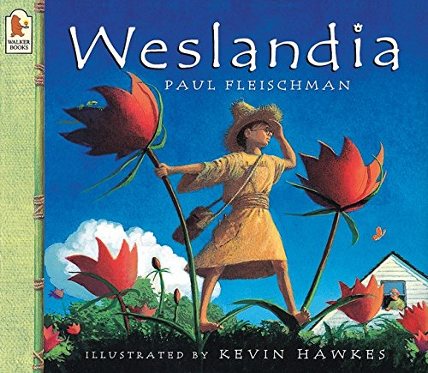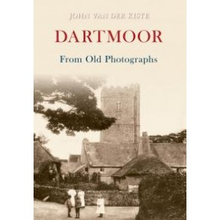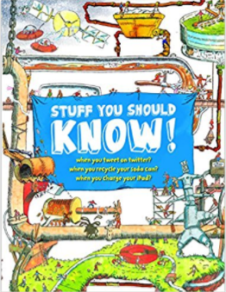

Following the expectations of the national curriculum, daily spelling lessons and aspects of grammar will be covered daily as part of the English lesson. Year 5 and 6 will have plenty of opportunity to practice their reading comprehension skills through inference and deduction. Y6 will be given plenty of time in lesson to ask about SATS style questions relating to their learning.

Art/ DT

MATHS

We will be focussing on practising SATS style questions for the first half of term. In both ARITHMETIC and REASONING the children will have the opportunity to practise their skills in all areas of Maths (4 operations) as well as extra work on algebra, angles, geometry, statistics and measurement.

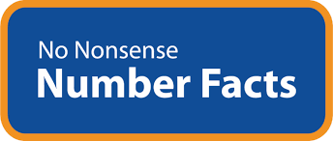****

This term we will focus on observational

drawings and sketching – the natural world. In

DT we will be designing and making fruit smoothies.

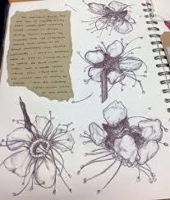

COMPUTING: **Online safety/ Digital literacy** Computingwork this term will involve sessions on e-safety to ensure that all children are aware of the dangers of the internet. We will also work on publishing/ editing skills.

**Bodmin Class** Summer term 2018 **Termly overview**

SCIENCE: Plants – living things

TOPIC Local Study: Dartmoor … Moor than meets the eye!

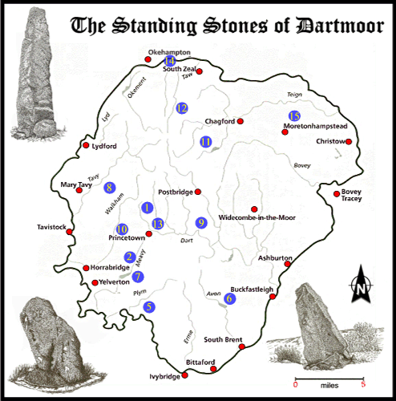

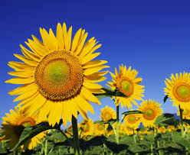

In our Science work, we will be exploring plants and identifying different ways a plant reproduces, explain the processes of reproduction and explain how different forms of reproduction is part of plant adaptation.

We will be looking at various aspects of heritage in Devon from prehistoric times up to the recent past, such as standing stones, Bronze Age field boundaries, Iron Age hillforts, medieval churches and the county’s industrial heritage of tin and copper mining and granite quarrying.

RE/SMSC/British Values

Our work will include exploring TOLERANCE and

RESPECT. We will be writing diary entries in

French: Le Sport We will have Y9 language leaders in to lead workshops on Sport as well as extra sessions on food and cuisine.

the first person, keeping memories of our year

in Bodmin class.