**Science: Living things and their habitats**

*Looking at the characteristics of living things. *Investigating plants and animals in the Rainforest and exploring what is unique about their habitat. *Recording findings using simple scientific language, drawings, labelled diagrams, keys, bar charts, and tables

**Art/ DT:**

**Art:** We will aim to improve our mastery of art and design techniques, including drawing, painting using a range of different materials.

**DT:** We will be designing, making and evaluating mini bottle biomes.

**Geography;**

We will be building on our locational knowledge of the World and investigating where the Rainforests of the World are situated.

We will also be studying physical aspects of Geography including Climate and the Water Cycle.

**English:**

We will study both fiction and non-fiction texts this term. Our first text is:-

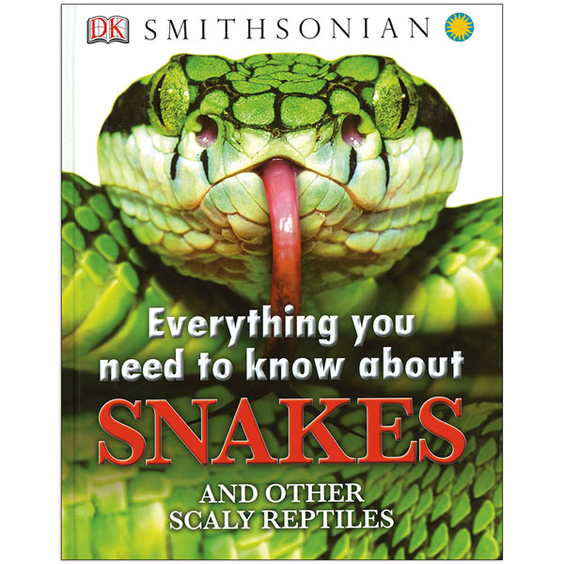

This will help the children to read books that are structured in different ways as well as planning writing by discussing writing similar to their own. This will enable them to understand and learn from its structure, vocabulary and grammar.

Our daily grammar lessons will focus on sentence structure, spelling and handwriting and Guided Reading sessions will encourage good reading habits.

**Would you like to visit a Rainforest?**

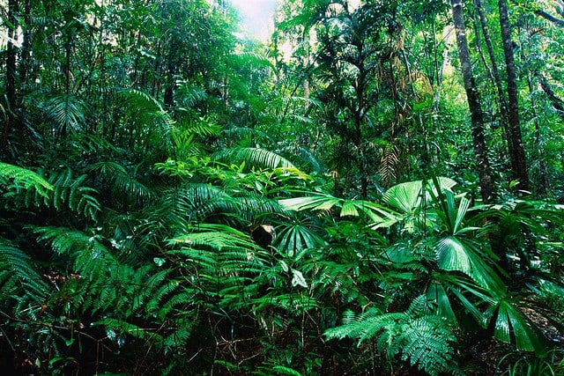

**Numeracy:** Our Maths this term will cover the following areas:

* Number and place value – working on partitioning and ordering of numbers.
* Addition and subtraction working with mental strategies and formal written methods.
* Multiplication and division –recalling known calculation facts and problem solving.

We will be investigating these areas of Maths with open-ended challenges to deepen our understanding of number.

**Physical Education**:

Outdoor games – hockey

Children will learn to play competitive games and apply basic principles suitable for attacking and defending.

During games, children will learn to compare their performances with previous ones and demonstrate improvement to achieve their personal best.

**RE/ PHSE/ CITIZENSHIP:** We will be learning about British Values with a focus on Tolerance towards others.

As part of our learning about the Rainforests, we will look into the impact of deforestation on the planet and what we can do to help sustain the World’s resources.

*If you have any resources at home that could help to support the class in their learning, and would be prepared to bring them into school, then these would be gratefully received.*

**With many thanks in advance for your support,**

**Mrs Gardner**