**Personal, Social, Emotional Development:**

This term, we will concentrate on self-confidence and self-awareness; allowing the children to express preferences about their activities through exploring environments, looking at photographs and providing more challenges and opportunities to reflect on their successes. All learning and development will be centred around: **• Playing and exploring • Active learning • Creating and thinking critically.**

**Communication and Language:** Objects will be used to remind children of experiences throughout the year to promote reflection on learning and recall/ memory skills. The children will be asked ‘how’ and ‘why’ questions about their experiences to texts, stories and events to deepen their vocabulary. We will be fostering children’s enjoyment of spoken and written language by providing interesting and stimulating play opportunities.

**Expressive Arts and Design/ Being Imaginative:** Opportunities will be provided indoors and outdoors to support the interests of the children e.g. role play in a cafe, building a ‘boat’ den or making an assault course. In DT, they will be constructing levers and pulleys, making joins, combining materials and using a mix of colour to explore how things can work together. They will use a range of properties, wet and dry, as well as selecting appropriate resources to help manipulate materials.

**Reading and Writing:**

**READING**: EYFS children will be anticipating key events in stories (predicting), talking through the sequence of a story and drawing conclusions about meaning (comprehension); joining in with imaginative play and role-play, acting out scenarios in character. To aid reading progress, we will provide children with simple texts to decode but also encourage them to decode words from more complex texts shared in class:

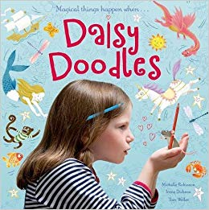 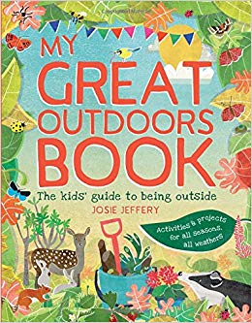

Peer reading (with older pupils) and 1:1 reading will be regular features and there will be time allocated to browse and enjoy books in the school library. Daily reading/ sharing books at home is greatly encouraged.

**WRITING**: Writing will be centred on personal experiences e.g.. weekend news or a trip to the beach. They will be expected to apply their phonics knowledge to what they write in meaningful contexts.

**Number:**

In Maths, we will be covering the following areas this term:

• Sequencing number – counting, sorting

• Solving problems and discussing solutions

• Understanding mathematical language (more, less, equal)

• Show an awareness of number bonds to 10

• Add and subtract single digit numbers

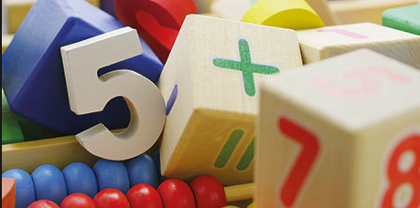

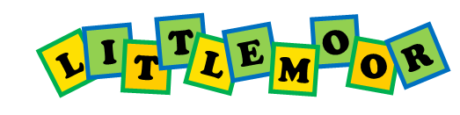**Termly Overview**

Early Years Foundation Stage

**Summer term 2019**

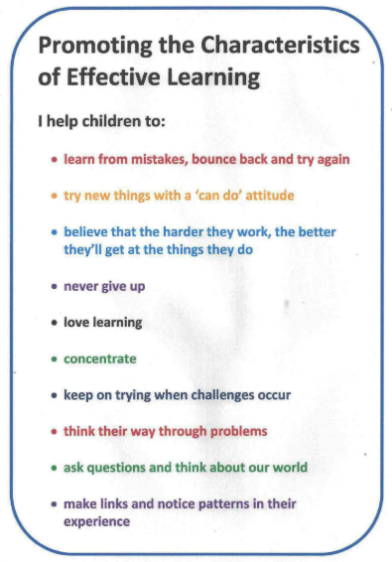

**PHYSICAL Development:**The following skills will be further developed: Jumping off an object and landing appropriately; forming recognisable letters and words; Show co-ordination in large and small movements; Handle equipment and tools effectively, including pencil for writing.

**Understanding the World:**

Children will be encouraged to talk about their feelings and to discuss their own special events. In Science, observations will be made of animals and plants, such as on our trip to Madewell Farm. Also, there will be opportunities to take care of our environment and look after equipment and plants; drawing simple maps and photographing in and outdoors.