**SCIENCE: Plants -** Pupils will use their local environment to observe how different plants grow. They will work scientifically, observing and recording the growth of plants and understand that they need light and water to stay healthy. Our trip to Madewell Farm will be a starting point with some extra planting back at school to investigate.

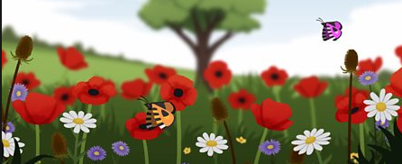

**ART/DT:**

ART: In Littlemoor, pupils will be further developing a wide range of techniques in using colour, pattern, texture, line, shape and form. Our Germansweek Church project will also take shape with watercolour masterclasses!

**DT**: Mrs Gardner will teach DT this term while Mrs Jolliffe teaches Music in Dartmoor. The outcome will be making sliders and flaps to tell a story, centred on our core text ‘*Daisy Doodles’*.

**HISTORY/ GEOGRAPHY:**

**History** – We will look at significant historical events, people and places in our own locality - our walk on Dartmoor will teach pupils about the early Stone and Iron Age. This will be developed further in KS2.

**Geography** – Using our place knowledge we will be comparing life in Britain to life in Japan. We will be using our geographical vocabulary to discuss the local area of Dartmoor, using fieldwork and observational skills to study this spectacular environment.

**ENGLISH:** Core texts studied this term include:

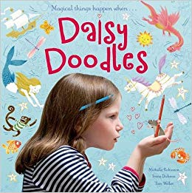 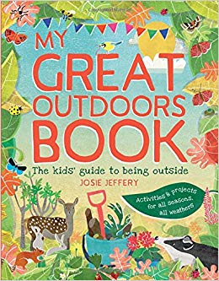

Daily Guided Reading sessions as well as peer reading will continue. We will focus on storytelling and ORACY through sharing ideas on varied texts in all subjects. Systematic Phonics teaching is daily as well as morning handwriting practice. Reading comprehension is always a focus, using deduction and inference to show understanding of the texts read. Please continue daily reading at home.

 **Termly Overview**

KS1 – Year 1 and 2

**Summer term 2019**

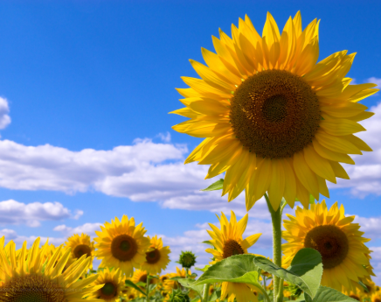

**MATHS:** In Maths, we will be covering the following areas this term:

• Identifying and representing number using objects and pictures, including the number line.

• Addition and subtraction

• Multiplication and Division

• Geometry - position and direction

• Statistics - pictograms, tally charts, simple tables



**PHYSICAL/OUTDOOR EDUCATION**:

Outdoor: Core skills of throwing, dribbling and kicking the ball, bat and ball, skipping and team games. FUNS programme for early physical literacy. Cricket and Athletics. Balancibility using the balance bikes.

FOREST SCHOOL: Sessions fortnightly with Rob Taylor, Dartmoor Ranger.



Please ensure your child’s PE kit (proper trainers) and wellies are kept in school. Reminders will be sent for Forest School – appropriate clothing please.

**PHSE:** Online safety lessons based around staying safe online using the following resources:



.

*Please talk to your child at home about their learning in school and encourage them to do Home Learning – they will be keen to share the wonderful enrichment opportunities they will have in school this term. Do ask if you have any queries about any of your child’s learning.*

*Many thanks for your ongoing support,*

*Mrs Petersen*