**Art:**

We will aim to improve our mastery of art and design techniques, including drawing and painting using a range of different materials to create Japanese Paper Lanterns and Hokusai’s Great Wave.

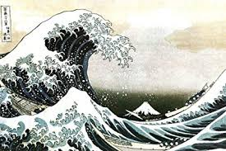

**Geography:**

We will build on our locational knowledge of the World and we will investigate modern day Japan. We will identify the position and significance of its latitude and longitude as well as comparing and contrasting Japan with the UK. We will be able to describe and understand key aspects of physical geography, including volcanoes and earthquakes. Later in the term, we will develop our fieldwork skills by observing, measuring, recording and presenting the human and physical features of Dartmoor using a range of methods.

Later in the summer term, we will be using our Geographical skills to

**Science: Plants, Animals and Evolution**

We will explore the requirements for life and growth in plants (air, light, water, nutrients from soil, and room to grow) and how they vary from plant to plant. We will use this information to work scientifically in planning and recording our predictions and making detailed observations.

Additionally, we will investigate human Evolution, from primates to Homo sapiens.

**Numeracy:** Our Maths this term will cover the following areas:

* **Money** – Add and subtract amounts of money to give change, using both £ and p in practical contexts.

* **Statistics** – Interpret and present data using bar charts, pictograms and tables as well as solving one-step and two-step problems.

* **Time** – Estimate and read time with increasing accuracy to the nearest minute; record and compare time in terms of seconds, minutes and hours; use vocabulary such as o’clock, am/pm, morning, afternoon, noon and midnight.

* **Position and direction** – describe positions on a 2-d grid as coordinates in the first quadrant, describe movements between positions as translations and plot specified points and draw sides to complete a given polygon.

**English:** 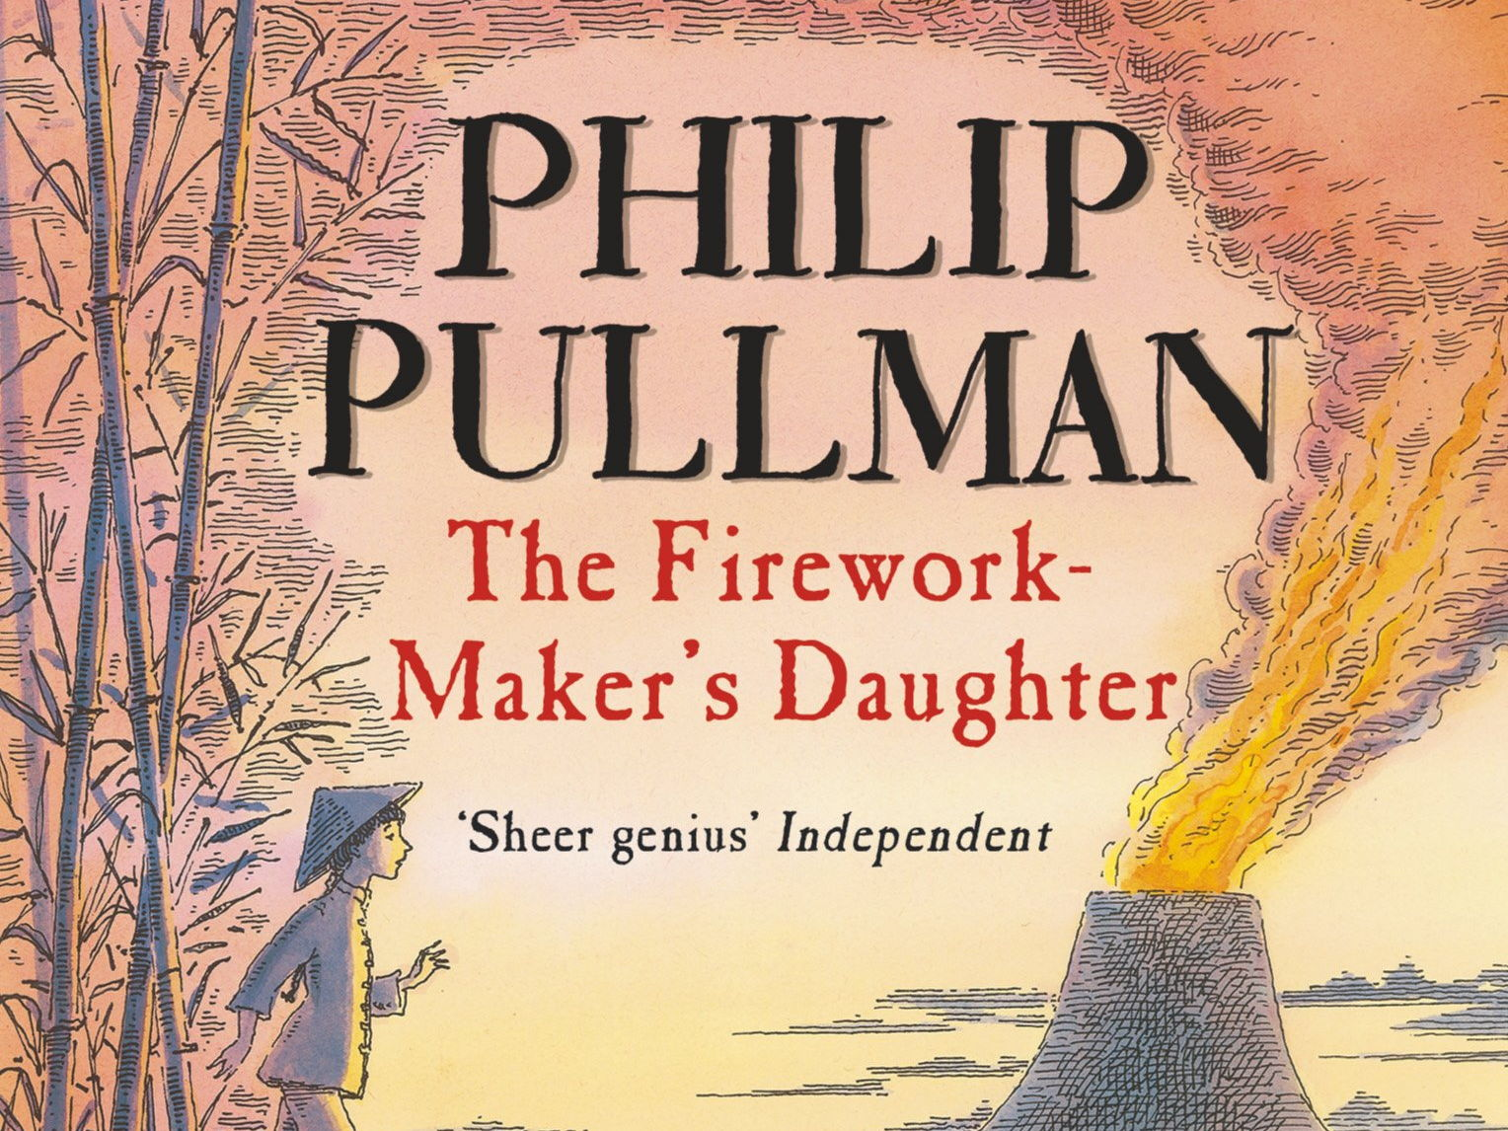

**Fiction** text – The Firework Maker’s Daughter by Philip Pullman.

This high-quality text will be used to teach children how to write Diary entries writing in the first person, using the past tense, conjunctions, fronted adverbials and recording events in a chronological order.

**Non- Fiction**: Letter writing. As we are heading onto Dartmoor for the second part of the summer term, we will be writing letters for insertion in special “Letterboxes” which we will “hide” on Dartmoor.

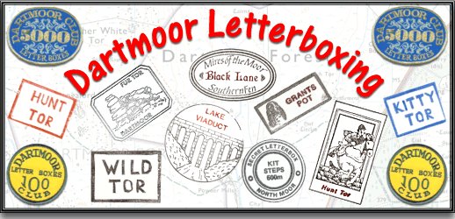

Home or Away?

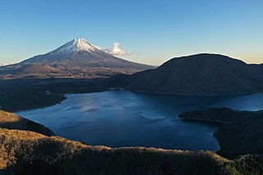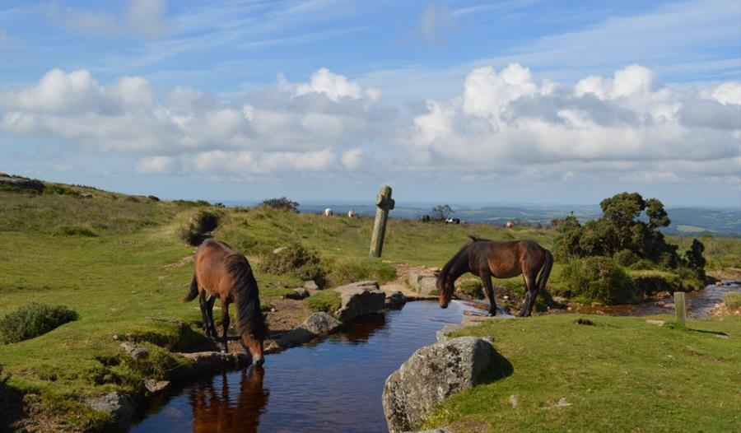

Japan or Dartmoor?

**History: Stone Age to Iron Age**

We will learn about the changes in Britain from Stone Age to Iron Age with a focus on Bronze Age technology and travel. We are hoping to visit a Bronze Age settlement later in the term.

**Physical Education**:

We will be playing competitive games including cricket and rounders. Children will be encouraged to develop their skills in communication and collaboration and interact competitively with each other. They will develop an understanding of how they can improve in different physical activities to achieve their personal best.

**RE/ PHSE/ CITIZENSHIP:**

This term will focus on Keeping ourselves Healthy. We will discuss Healthy Eating and Personal Hygiene.

We will compare Christianity with people during the Stone Age and investigate Stonehenge.

*If you have any resources at home that could help to support the class in their learning, and would be prepared to bring them into school, then these would be gratefully received.*

**With many thanks in advance for your support,**

**Mrs Gardner**